Project Design Phase Problem – Solution Fit Template

Date | 13 July 2026
Team ID
Project Name | DarshanEase
Maximum Marks | 2 Marks

Problem – Solution Fit Template:
The Problem-Solution Fit simply means that you have found a problem with your customer and that the solution you have realized for it actually solves the customer’s problem. It helps entrepreneurs, marketers and corporate innovators identify behavioral patterns and recognize what would work and why

Purpose:
- Solve complex problems in a way that fits the state of your customers.
- Succeed faster and increase your solution adoption by tapping into existing mediums and channels of behavior.
- Sharpen your communication and marketing strategy with the right triggers and messaging.
- Increase touch-points with your company by finding the right problem-behavior fit and building trust by solving frequent annoyances, or urgent or costly problems.

Understand the existing situation in order to improve it for your target group.

Template:
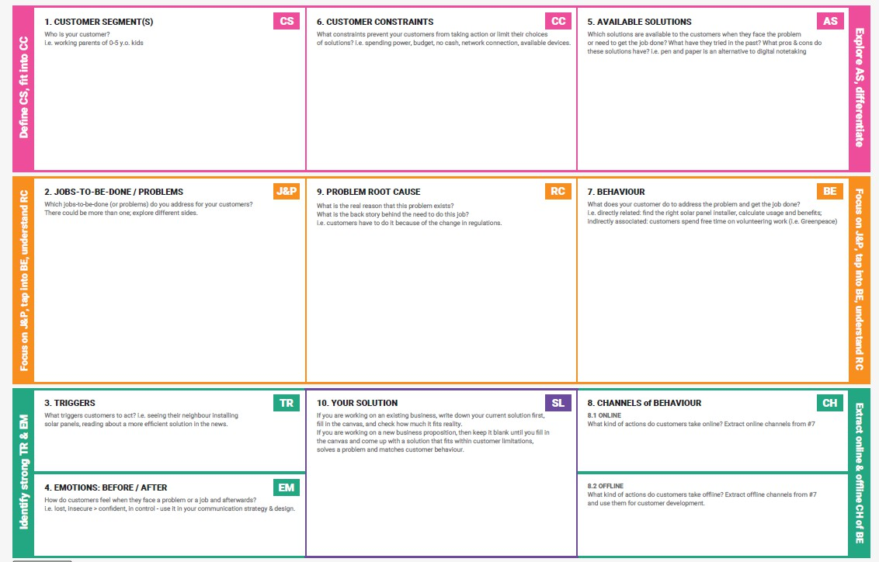
References:
- https://www.ideahackers.network/problem-solution-fit-canvas/
- https://medium.com/@epicantus/problem-solution-fit-canvas-aa3dd59cb4fe

Problem–Solution Fit (DarshanEase)
- Customer Segments (CS)
  - Devotees visiting temples
  - Pilgrims traveling long distances for Darshan
  - Temple organizers and administrators
  - People who want to donate to temples online

Customer Constraints (CC)
  - Long waiting queues in temples
  - Lack of reliable temple information online
  - Difficulty planning temple visits in advance
  - Traditional donation methods lacking transparency

Available Solutions (AS)
  - Visiting temples physically and waiting in queues
  - Searching temple information on multiple websites
  - Manual booking systems used by few temples
  - Offline donation systems

Jobs-To-Be-Done / Problems (JP)
  - Find accurate temple information and timings
  - Book Darshan slots in advance
  - Avoid overcrowding and long waiting times
  - Donate securely to temples

Problem Root Cause (RC)
  - Lack of centralized temple information platforms
  - Absence of digital booking systems in many temples
  - Poor crowd management mechanisms
  - Limited online donation facilities

Behaviour (BE)
  - Devotees search online for temple details
  - Ask friends or family about temple timings
  - Travel long distances without guaranteed entry
  - Wait for hours in queues for Darshan

Triggers (TR)
  - Festival seasons and peak temple visits
  - Desire for a peaceful Darshan experience
  - Increasing use of digital platforms for booking services
  - Need for convenient donation systems

Channels of Behaviour (CH)
  - Temple websites and mobile applications
  - Social media and online forums
  - Travel and pilgrimage websites
  - Word-of-mouth recommendations

Emotions (Before / After) (EM) Before using DarshanEase
  - Frustrated due to long queues
  - Uncertain about temple timings
  - Confused by scattered information

After using DarshanEase
  - Confident about temple visit planning
  - Relaxed due to pre-booked Darshan slots
  - Satisfied with secure donations

Your Solution (SL)
DarshanEase is a digital temple management and Darshan booking platform that allows devotees to:
  - Discover temples easily
  - Book Darshan slots online
  - Make secure donations
  - Access temple details and facilities
  - Experience a smooth and organized pilgrimage journey

